**Our World In Crisis Hackathon**

**The UCL Induction Week Meet and Envision Online Hackathon**

**with IFRC Red Cross, OXFAM, UN, Microsoft, IBM, Intel and NTTDATA**

*“A chance for you to meet students from across the University, work collaboratively to share ideas using online tools, and make a pitch video your best idea to help a major charity.”*

**Moodle page:** <https://moodle.ucl.ac.uk/course/view.php?id=31181>

Register as part of a Team here:

<https://forms.microsoft.com/r/Fi4a7TDGsB>

The Hackathon runs from **Tuesday 27th September 2022 to Sunday 2nd October 2022**

(One live event, several async events, and your own study time)

Coordinators:

UCL: Prof Dean Mohamedally, Prof Graham Roberts, Sheena Visram  
UN: Dr Husna Ahmed OBE

Microsoft: Prof Lee Stott, Chris Noring

IBM: Prof John McNamara

Deadline for submission of your hackathon entry on Moodle:

**5pm Sunday 2nd October 2022**

Welcome to UCL!

You’re here to ***Change the World***.

On behalf of UCL, The Faculty of Engineering Sciences, and the Department of Computer Science, we are thrilled to be hosting this **Meet and Envision** hackathon as part of your induction week activities (coding skills not needed!).

Form a team and watch the live launch event where the charities will introduce their needs and priorities. Then during the hackathon week meet up with your team members, work on the **A World In Crisis** challenge theme allocated to your team, create and submit a 3-5 minute video embedded is a simple website to showcase your results.

Your hackathon entry will be reviewed by the charities, industry sponsors, and UCL staff to select the winners, and prizes awarded to the best entries.

We look forward to seeing your ideas, the best of which could also be taken forward as future projects if they are good enough!

**Benefits**

Get to know others and experience online collaboration using UCL standard tools and processes. You will explore a meaningful and engaging topic with the goal of creating a short video of your ideas. Teams will be assigned, with a mix of students from different departments and degree programmes.

You should be courteous and appreciate that students you work with will be from all over the world, with very different backgrounds and approaches. Collaborate with each other to contribute and help develop the best of ideas from all your team members.

After the launch session you should **set aside 6-7 hours of your time with your team** between Tuesday 27th September and Sunday 2nd October to work on your entry. You will build familiarity with UCL and Microsoft tools, UCL online systems, group working, and make new friends in the process!

**Getting Ready:**

* + For a general overview of your 2022-23 Academic Year see: [Your UCL education in the 2022/23 academic year | Students - UCL – University College London](https://www.ucl.ac.uk/students/your-ucl-education-202223-academic-year)
  + Visit the Connected Learning site: <https://moodle.ucl.ac.uk/course/view.php?id=9119>
  + Make sure your UCL account email is working correctly. All information from UCL will be sent to you via your UCL email address, not via any other email address you may have. Also, all email you will send to UCL staff must come from your UCL email. You need to get used to checking your UCL email multiple times per day (turn on notifications!).
  + Your UCL account also gives you full access Microsoft 365 services, including Microsoft Office! Access 365 using: <http://portal.office365.com>.
    - Make sure you are not using Microsoft 365 with any other previous (personal) account.
  + Install Microsoft Teams and login with your UCL account.
  + [Install OneDrive from Microsoft 365](https://support.microsoft.com/en-us/office/get-started-with-onedrive-work-or-school-b30da4eb-ddd2-44b6-943b-e6fbfc6b8dde) as well. This will allow you to backup your work and easily share files. OneDrive is available for PC, Macs, iPads and iOS and Android phones. Again login with your UCL account, not any account you may already have.

The two video conferencing tools that UCL supports are Zoom and Microsoft Teams. Zoom is typically used for large events and online lectures, otherwise Teams is used for most other smaller and personal online interaction. The Hackathon will use Zoom for the launch event, otherwise you can use Teams for your team working.

To be ready install Zoom (<https://zoom.us>). You don’t need to create a new account to use Zoom, your UCL account gives you access. To login to Zoom go via <http://ucl.zoom.us> using your UCL account with the screen that says **Single Sign On (SSO)** – it uses your UCL id and password, do not log in with any other personal account if you do have one. Use ‘ucl’ as the SSO name if prompted when logging in.

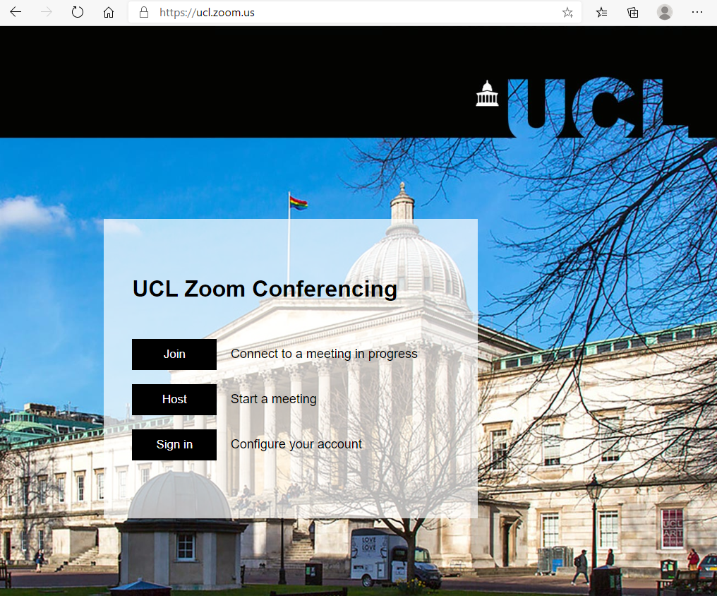

At 5pm UK time on Tuesday 27th September 2022 you should click the Zoom link given to you

in via

email to take you to the Launch Webinar session. The session ends at 6:30pm UK time.

Videos from each of the Launch Webinar speakers will be available on the Moodle page shortly afterwards.

**What you need to do**

The list of tasks below describe what you need to do at each stage of the hackathon.

You should create:

* A MP4 video presenting your results.
* A simple website to embed your video in (instructions on how to create the website are given later in this document).

**Hackathon Task List**

*“A lawyer, an engineer, and an architect walk into a room….”*

**Task 1:** The first meetings!

Getting to know each other in your team will be a key skill and formality to get used to at UCL. As you get to know each other in your teams, you should appoint a team leader for your group by way of a vote. If you are having difficulties in picking a team leader let us know by emailing the module tutors.

As you will be using UCL approved software, starting with Microsoft 365 tools, the team leader should create an MS Teams group for your team to join. Spend some time getting to know each other in your teams, or in person on campus, and finding out about why you are on the degree that you chose, and what you hope to gain from it. Learn how to use Teams features such as setting up a channel, uploading documents and looking at the apps that it has within it.

You have a choice of the following five themes to explore:

1. Climate Change
2. Energy Crisis
3. Poverty and War
4. Children in Harms Way
5. Equitable Access for All.

From those 5 themes, then choose one of the following solution pathways:

* Global Conversations – Getting people talking and exchanging ideas about our World In Crisis;
* Intelligent & Insightful – Designing for data collection and usage that tells the stories that matter.
* A Community Voice – Designing solutions that get people involved and working together, so they can have more impact.
* Fair Access to Technology – Providing access to technology in a way that is affordable and works in many different environments.
* Circles of Influence – Enabling young people and other community members to better advocate for change.

Once you have discussed and agreed to work on a theme and pathway please do give your team a name!

Next up, the team leader should go into OneDrive, set up a shared folder (e.g. “Induction Week Hackathon 2022”) with your team members using their UCL email addresses, and creating some **shared** documents which everyone can write content into. You could begin with 1. Word Document for Meeting discussions, 2. PowerPoint slides of each person’s ideas, 3. Excel sheet for pro’s and con’s, and so on. You should practice engaging others in your team using documents and ensuring everyone knows how to access documents and enable sharing.

**Working on shared documents for learning together and revision will be a very powerful tool!**

Side note for interested students – have a look here at the types and categories of data storage that UCL’s Information Services Division (ISD) have - [Data storage options at UCL](https://www.ucl.ac.uk/isd/sites/isd/files/ucl_data_storage_options.pdf). Note that Google Docs and Dropbox are not appropriate for any documents and data that may have personally identifiable information.

**Task 2: *Brainstorm with each other***

Schedule the next few tasks with your team.

Spend 1 hour brainstorming in an MS teams (or Zoom) session using [Mentimeter](https://www.mentimeter.com/) to capture and categorise individuals ideas.

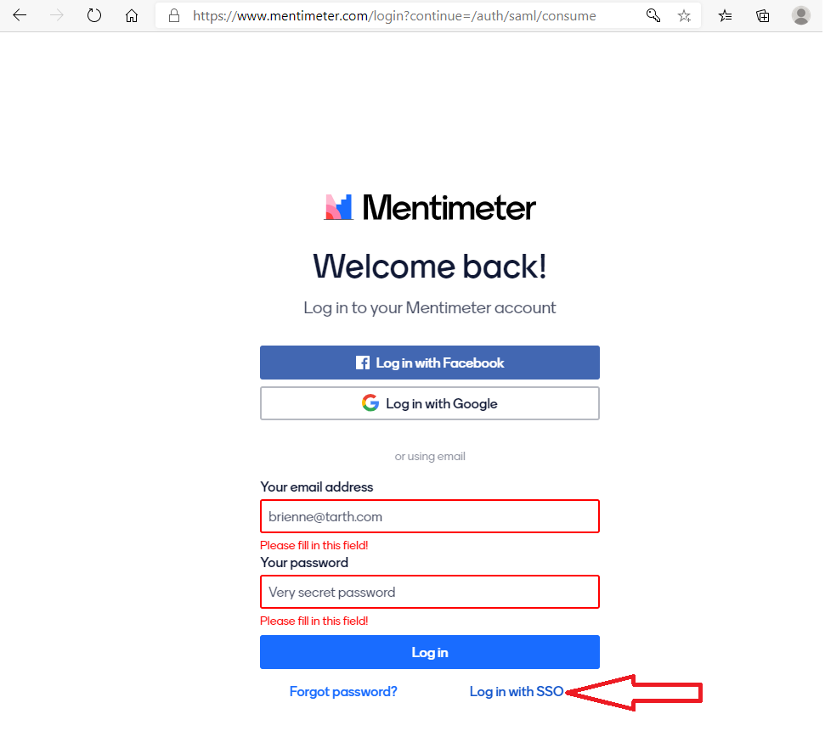

Everyone should sign in using UCL SSO (Single sign on) on [www.mentimeter.com](http://www.mentimeter.com). Use the link pointed at by the big red arrow above, rather than enter your email and password on the default login form. When prompted for the organisation name use ‘ucl’.

Spend a little time on Mentimenter to familiarise yourself with the tool and its capabilities.

Then arrange a 1 hour synchronous MS Teams call with your team members – be considerate to those who are in different time zones.

Each member of the team should contribute ideas and respond to and provide their own opinions on at least two other ideas on Mentimeter to the rest of the team regarding the theme allocated. Make sure you are inclusive of all team members!

Mentimeter can also be used to rank which ideas are most popular in the team.

Share your opinions to create a word cloud (or try out other approaches) that represents the thoughts of the entire team.

Another good tool to try out for data collection is <http://forms.microsoft.com>. This will let you create survey forms easily. Remember to always ask consent for use of data when you do data collection. In your own time you should go through the UCL GDPR and data protection training course, [found here](https://www.ucl.ac.uk/data-protection/data-protection-overview/online-training/data-protection-online-training).

Once you have the idea that everyone has voted fairly on and chosen, download this information as a slide/image to use in your MP4 video.

**Task 3**: ***Draft out your team’s ideas***

*“What did the confident*whiteboard*say to the dry erase marker? I am remarkable!”*

Trello is an excellent collaborative project working tool. You can access it via the Apps category section within MS Teams itself, or use it normally through a browser.

Go to [www.trello.com](http://www.trello.com) and register – their Single Sign On is not yet approved on UCL’s list so you will have to register normally for this.

Visit the Trello Channel on YouTube to learn how to use it: <https://www.youtube.com/c/trello/featured>

Also use MS Whiteboard by signing into it with your UCL credentials here: <http://whiteboard.microsoft.com> – you can share with the others in the team as you draw.

Mural (another app available within MS Teams, in the apps category) is the solution of choice with many industries to share ideas and drawings, and there are many more out there.

Save the ideas that you have generated to use in Task 4.

**Task 4: *Collaborate on building a document and writing a script together***

Once you have defined your theme’s ideas, prepare a short briefing document that outlines the solution as a script for a 3-5 minute video with illustrations, sketches, images of ideas, team members speaking, acting or role playing. On your MS OneDrive account share a folder via for the team members to store the file(s) in, and contribute together in developing the material together using Microsoft Office 365.

In some disciplines of study, we ask our students to prepare a MoSCoW list at this point of a project design. What that means is you would classify the ***requirements*** of your solution as “Must haves, Should haves, Could haves and Would like to haves”. Another way of looking at the requirements is to see what you already have, what you will need and what is not yet known if it is possible.

From a video editing perspective, you could consider the introduction to the problem you are considering to solve, the development of the idea with illustrations, and the ending considering what viewers will learn and appreciate from it.

Especially important at this scripting stage, we have prepared a unique opportunity to speak to industry mentors about your ideas via Reddit channels. Here you can discuss the problems you are going to explore in your team, and your proposed solutions - so consider making use of this and reaching out, as you develop your ideas.

**UCL and IBM Reddit hackathon channel -** [**https://www.reddit.com/r/UCLDesignHack/**](https://eur01.safelinks.protection.outlook.com/?url=https%3A%2F%2Fwww.reddit.com%2Fr%2FUCLDesignHack%2F&data=04%7C01%7Cd.mohamedally%40ucl.ac.uk%7Cf12e050c529c47a16aae08d980349e15%7C1faf88fea9984c5b93c9210a11d9a5c2%7C0%7C0%7C637681785736508498%7CUnknown%7CTWFpbGZsb3d8eyJWIjoiMC4wLjAwMDAiLCJQIjoiV2luMzIiLCJBTiI6Ik1haWwiLCJXVCI6Mn0%3D%7C1000&sdata=VUklAkec8cXN%2Fx2Csn8lnjFuwhw6Mr%2FJLxcvUKvIzvQ%3D&reserved=0)

**NTT Data Reddit channel -** [**https://www.reddit.com/r/UCLDesignHackNTTData/**](https://eur01.safelinks.protection.outlook.com/?url=https%3A%2F%2Fwww.reddit.com%2Fr%2FUCLDesignHackNTTData%2F&data=04%7C01%7Cs.visram%40ucl.ac.uk%7Cdd70ea280bb44fafc9af08d97e790372%7C1faf88fea9984c5b93c9210a11d9a5c2%7C0%7C0%7C637679880474674924%7CUnknown%7CTWFpbGZsb3d8eyJWIjoiMC4wLjAwMDAiLCJQIjoiV2luMzIiLCJBTiI6Ik1haWwiLCJXVCI6Mn0%3D%7C1000&sdata=yURkbs3XcXVTQZo7mbZ9OsuMFdcT782Nd20qK8Ug1%2B4%3D&reserved=0)

**Microsoft Reddit channel -** [**https://www.reddit.com/r/UCLDesignMicrosoft/**](https://www.reddit.com/r/UCLDesignMicrosoft/)

**UN-ANCSSC (Charities) Reddit channel -** [**https://www.reddit.com/r/UCLDesignHackANCSSC/**](https://eur01.safelinks.protection.outlook.com/?url=https%3A%2F%2Fwww.reddit.com%2Fr%2FUCLDesignHackANCSSC%2F&data=04%7C01%7Cs.visram%40ucl.ac.uk%7C014eae82f1d14ff1884b08d97e78bf7b%7C1faf88fea9984c5b93c9210a11d9a5c2%7C0%7C0%7C637679879343223090%7CUnknown%7CTWFpbGZsb3d8eyJWIjoiMC4wLjAwMDAiLCJQIjoiV2luMzIiLCJBTiI6Ik1haWwiLCJXVCI6Mn0%3D%7C1000&sdata=G3uCKMtyUsH2CB4rC5vR1%2BL0HJidD633WufkabFWrRM%3D&reserved=0)

**Task 5: *Define a mock-up of what your solution will look like***

Your ideas may take many different forms. From processes, to machinery, to website and apps and other meaningful ways to help the charities achieve their goals. This is the key part of the week’s event.

You need to be able to clearly and straightforwardly explain your ideas, so that they are accessible to a general audience. You could use PowerPoint, Whiteboard or Sketchup, or merge photographs, images or video. Preferably generate this content yourselves, if you do use content found elsewhere the make sure it is copyright free or usable under the Creative Commons license. You may also have a look at Figma ([www.figma.com](http://www.figma.com)) to do a quick sketch on this. For other styles, smartphone images of simple pen sketches and blueprints are also fine, so long as they are legible and have clear legends on what is explained.

This will go into your video, with your team members explaining it as a speech-over.

**Task 6: *Talk and publicise about the solution!***

UCL has several ways that students can talk about their work publicly. You could put up a Medium post ([www.medium.com](http://www.medium.com)) about it, or add it to your own website if you have one, or set one up on <http://reflect.ucl.ac.uk>). You may already be on LinkedIn (also free to access via your UCL account), which would also be a good way to publicise your teams work.

We would like you set up a website with your video. Microsoft provides free cloud credits to use their [Azure Static Web Apps](https://docs.microsoft.com/en-us/azure/static-web-apps/getting-started?tabs=vanilla-javascript). More information on the Azure credits for this will be on the [Moodle site here](https://moodle.ucl.ac.uk/course/view.php?id=31181).

**Task 7: Produce your video and website!**

To complete the hackathon the team creates their video and website. Everyone should have been given a fair chance to be included in the video and explain a portion of the ideas. **Make sure you have included your names and website URL in the video via the titles at the start.**

The video should be 3-5 minutes in length. If it goes over by a short time we will allow this (this isn’t marked work!), but remember you want to make an effective presentation of your ideas to people viewing the video, so don’t go on for too long and bore them!

To create the video content you can opt for a slideshow [presentation in PowerPoint narrated](https://support.microsoft.com/en-us/office/record-a-slide-show-with-narration-and-slide-timings-0b9502c6-5f6c-40ae-b1e7-e47d8741161c) and dubbed with an audio stream. You can also use Microsoft Video Editor on Windows 10 if you have the latest updated version, or Apple iMovie if you are a Mac user. Don’t forget to turn on [subtitling for accessibility](https://www.ucl.ac.uk/teaching-learning/news/2018/mar/download-best-practice-guide-how-subtitle-your-video-based-teaching-materials)! Do not use any copyrighted audio in your videos.

Using your smartphones, iPads, or similar devices to create the video and other content is fine, and probably more convenient! Most likely you already have the apps you need installed or there are many free options available from app stores. Via your UCL account you have full Microsoft 365 access on iOS and Android devices, including the OneDrive app that makes file sharing very easy.

If you want to you could also create more polished videos by using software such as Adobe Premiere if you have access to it, or use an Open Broadcast System solution such as Streamlabs OBS ([www.streamlabs.com](http://www.streamlabs.com)). This level of video production is not required, but you are welcome to use any other video editing tools, such as Microsoft Video Editor, Apple iMovie, Final Cut and others. Of course, you can always use your phone camera and various apps on your phone, and your phone camera is likely to be much better quality than from a webcam!

The video should be submitted in MP4 format, so use this as the default format when creating video content. The video recording (a .mp4 file) should be uploaded to your OneDrive in a folder with **permissions set for public.** Make sure your video is accessible, with captions/subtitling available.

**Task 8: Set up a website to host your video!**

Your website should be implemented using a Microsoft Azure Static Web App and will be hosted in the cloud on Azure.

You should sign up for an Azure Account at:

<https://azure.microsoft.com/en-gb/free/students/>

Use your UCL account email address when you sign up, so that your Azure account is correctly connected with your UCL details.

These resources show how to set up your website:

* Video [**https://youtu.be/v4n0AU2xlOo**](https://youtu.be/v4n0AU2xlOo)
* GitHub Repository participants can use as template <https://github.com/softchris/swa-copy>
* Example of deployed project site <https://gentle-bay-0c931e90f.1.azurestaticapps.net/>

**Task 9: Submit your results!**

The URL links to your video and website should be submitted through the upload link on the [Moodle website for this event here](https://moodle.ucl.ac.uk/course/view.php?id=31181).

The video URL should be a SharePoint link, make sure that the permissions allow it to be viewed (not edited!) by anyone who has the link.

The website URL will be the one provided by your static web app.

If the video recording is high enough quality we may ask to have a full high-resolution download copy for UCL to publish it further.

The deadline for all uploads is **5pm, Sunday 2nd October 2022.**

**Good Luck**!